Design and Simulation of High-Efficiency Buck Converter (DC-DC Step-Down)

OBJECTIVE
To design a high-efficiency non-isolated buck converter to step down 12V to ~6V, focusing on switching performance, ripple minimization, and loss optimization.

SYSTEM OVERVIEW
- The system architecture includes:
- A PWM-controlled MOSFET (AO6408) as a switching device
- A Schottky diode (MBR745) to handle freewheeling current
- An LC filter to minimize ripple at the output (143 µH inductance, 200 µF capacitance)
- The system is operating in Continuous Conduction Mode (CCM) to minimize ripple in the current delivered to the load.

KEY EQUATIONS
- Voltage Conversion:
Vout = D.Vin
- Inductor Ripple Current:
I_{L} = (V_{in} – V_{out}).D
L.f_{s}
- Output Voltage Ripple:
V_{out} ≈ I_{L}
8 f_{s}.C

DESIGN SPECIFICATIONS
- Vin: 12 V
- Vout: ~5.7 V
- Load: 1 Ω (~5.7 A)
- Switching Frequency: 25 kHz
- Duty Cycle: ~0.5
- Output Power: ~32-34 W

SCHEMATIC

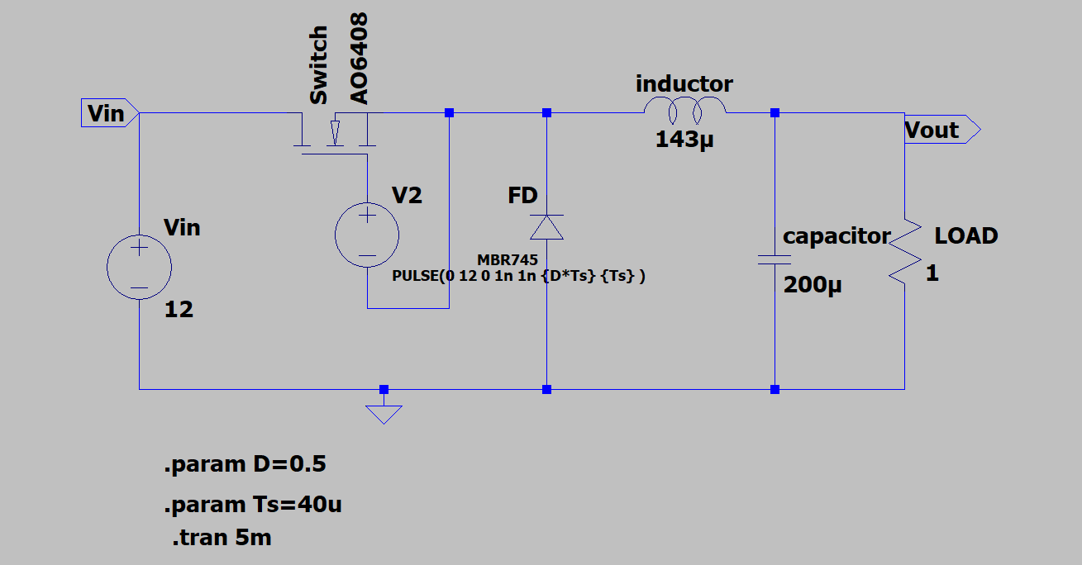

PERFORMANCE
- Efficiency: ~93-94%
- Total Losses: ~2-2.5 W
- Dominant: Diode conduction loss (~1.5 W)
- Output Ripple: <2%
- Transient Response: <1 ms settling time

OUTPUT

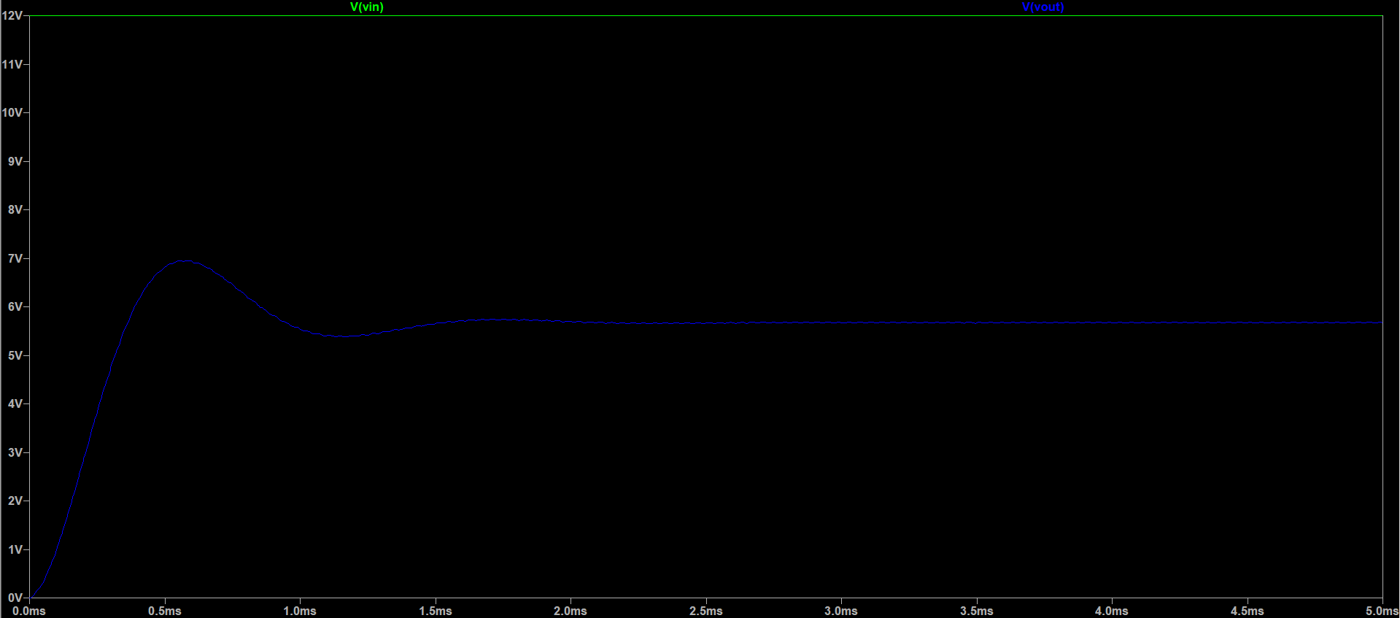

ERROR ANALYSIS
- Non-ideal component losses: MOSFET switching losses, diode forward drop, and inductor DCR reduce efficiency and cause deviation from ideal output.
- Open-loop operation & parasitics: Fixed duty cycle and effects like capacitor ESR and noise lead to output voltage variation and ripple under load/input changes.

IMPROVEMENTS
- Closed-loop feedback control (PWM regulation): This ensures a stable output voltage under varying line and load conditions, as well as a faster transient response.

- Employ synchronous rectifier (substitute MOSFET for diode switch): This minimizes conduction losses, resulting in a substantial increase in efficiency.

CONCLUSION
The project has shown a practically efficient design of a buck converter circuit and has emphasized some important concepts in power electronics that are often encountered in industry and real-world applications.

